ASSIGNMENT-1

**TASK**: Create a VPC with 2 subnets and 2 route tables and internet gateway

* Launch 3 instances
* Attach 1 instance with EBS
* Attach 2 instances with EFS
* VPC Concept:
* Search for VPC in search space of AWS home page and click on VPC

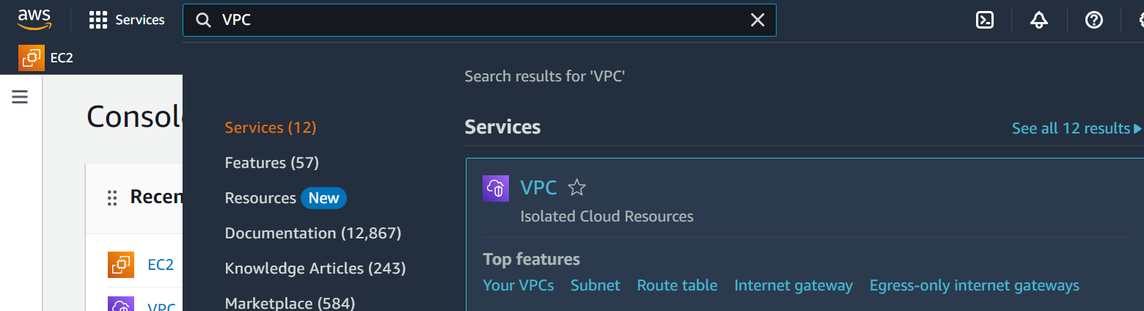

* Now click on Your VPCs option from VPC menu (left panel/side) of VPC page

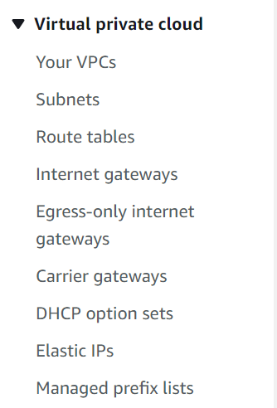

* Now click on Create VPC to create our custom VPC.
* We have to fill few details for our VPC and finally click on Create VPC.

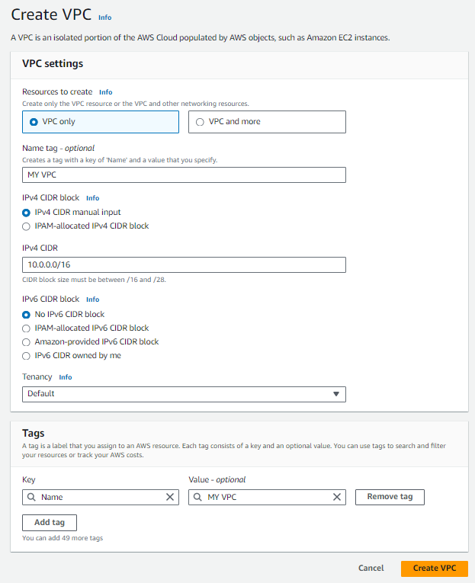

* We have created our custom VPC successfully. Now click on Internet gateways from menu and click on Create internet gateway.

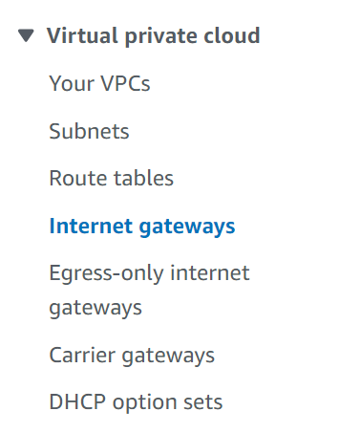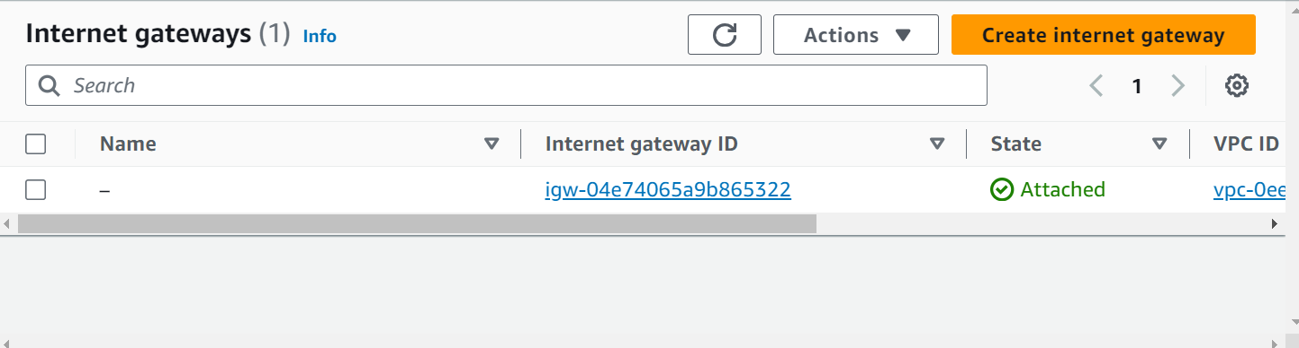

* Now, we have to name our internet gateway and finally click on Create internet gateway.

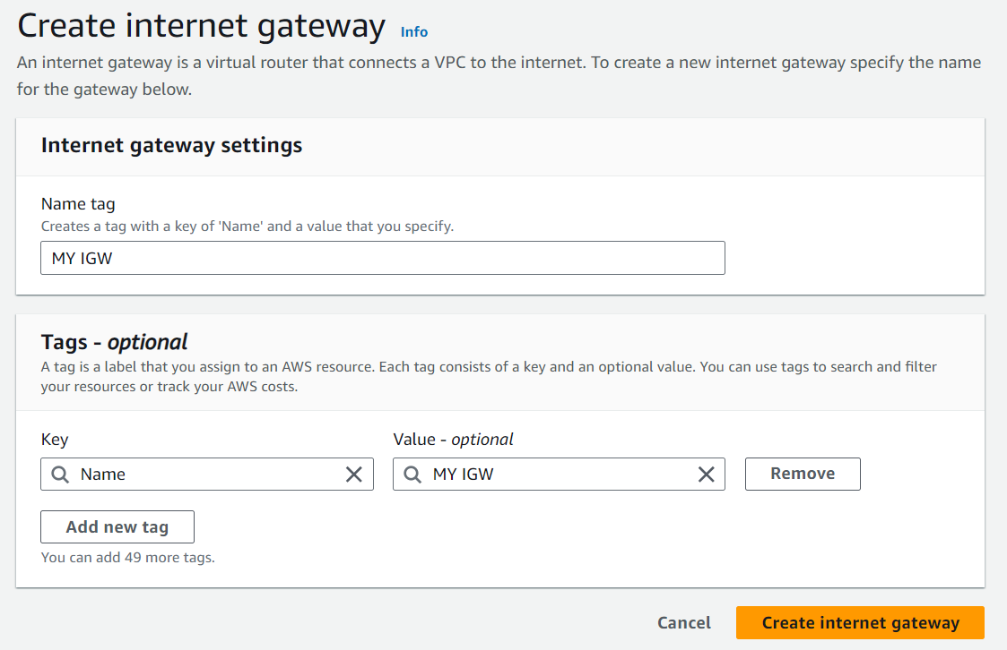

* Now click on Actions and click on Attach to VPC option.

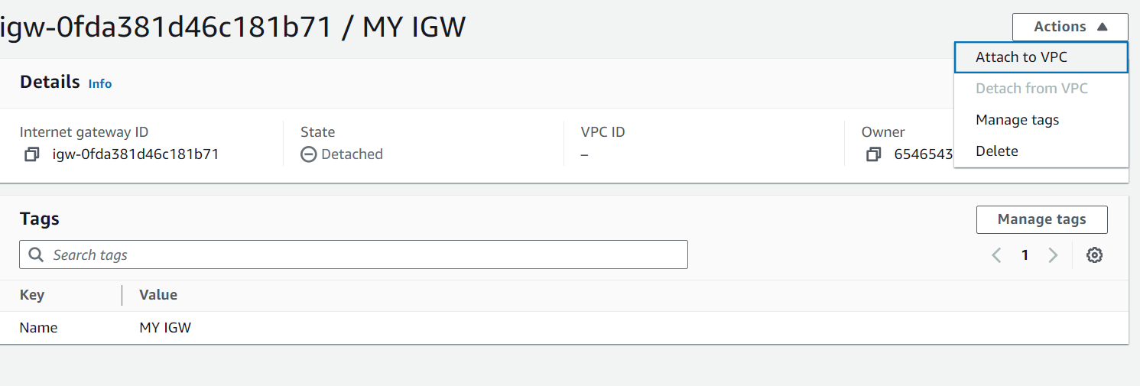

* Under Available VPCs section, select our custom VPC that we already created and Finally click on Attach internet gateway.

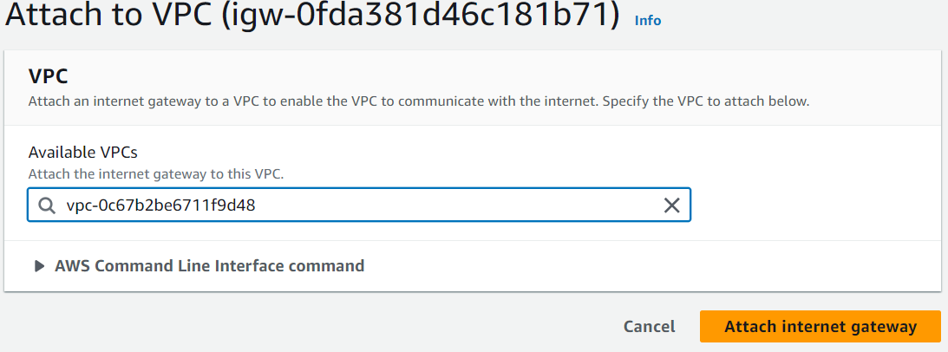

* Now we have to create 2 subnets (one is public and another one is private).
* TO create a subnet, first we need to select our VPC.

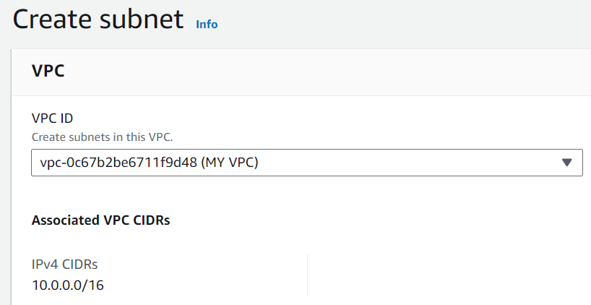

* Then we have to mention some details like name our subnet, we have to select Availability zone and we have to enter CIDR under IPv4 subnet CIDR block.

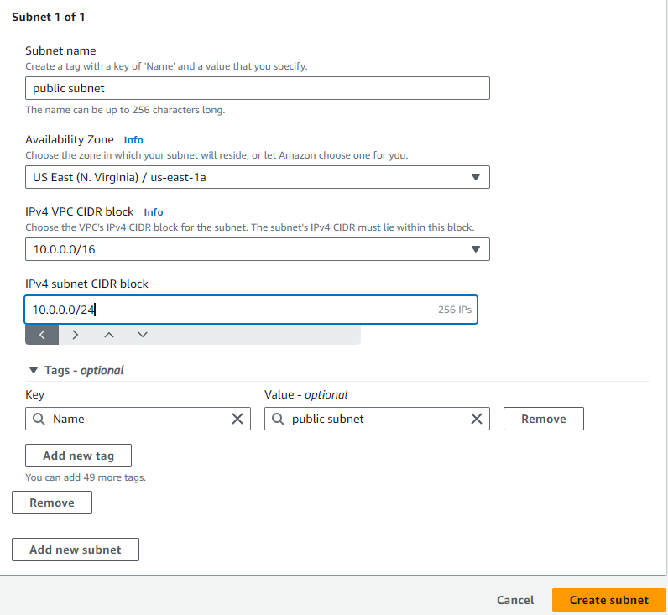

* Now we have to create one more subnet (name: private subnet, Availability zone is 1b and CIDR is 10.0.2.0/24)
* we can see our two subnets.

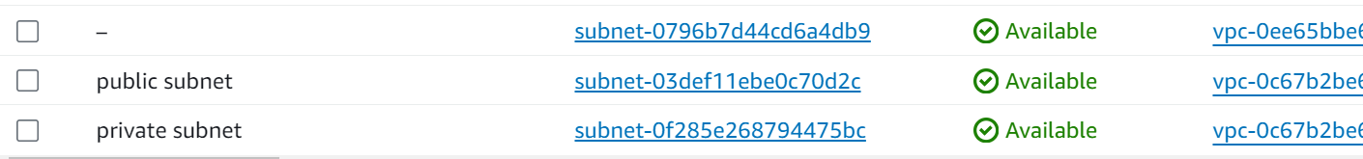

* Now we have to create 2 route tables (one is public and another one is private). Click on Route tables from menu and click on Create route table



* Give name to route table and select our custom VPC and finally click on Create route table.

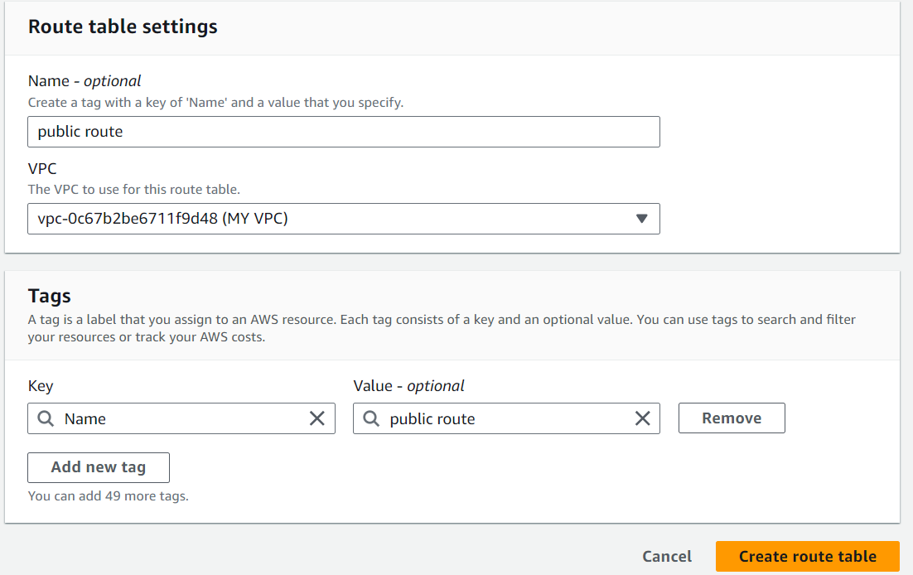

* Now click on Actions, click on Edit routes, click on Add route. Select 0.0.0.0/0 as Destination, Select Internet gateway from drop down list and choose our Internet gateway and finally click on Save changes.

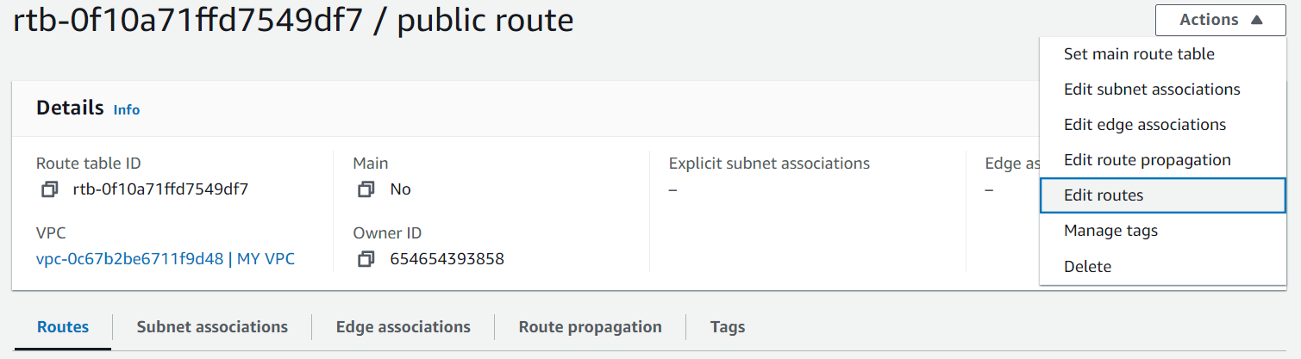

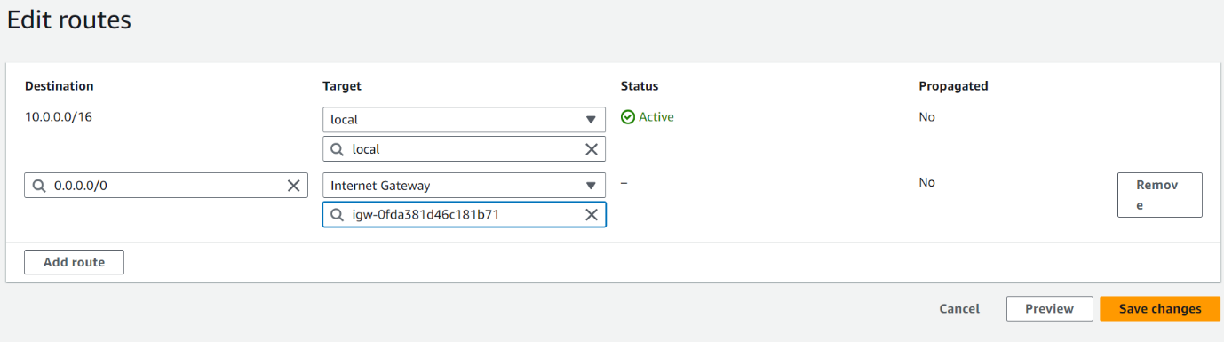

* Now click on Subnet associations and Edit subnet associations. Select public subnet check box and Save associations.

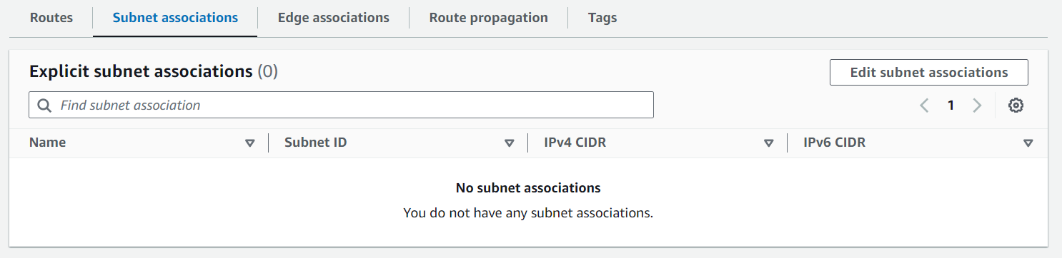

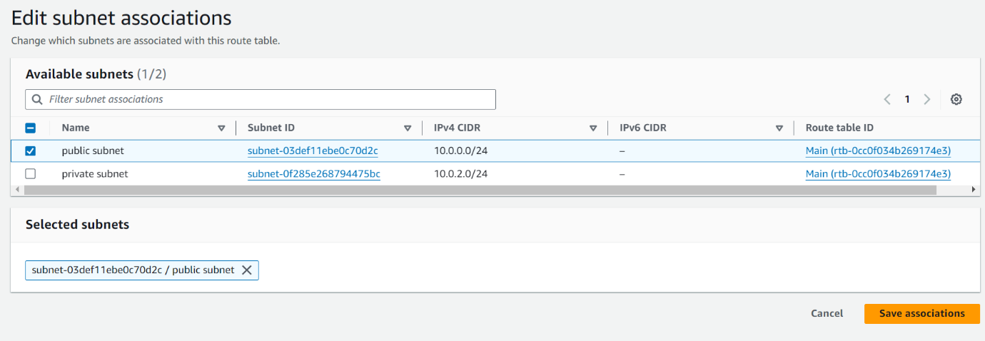

* Create one more route table (private route) and associate with private subnet.
* Note: Here for private route table, we are not going to give internet gateway because we want to make it as private. If we give internet gateway it will become public.
* EBS volume:
* Search for EC2 in search bar in AWS home page and click instances form menu and click on Launch instance.

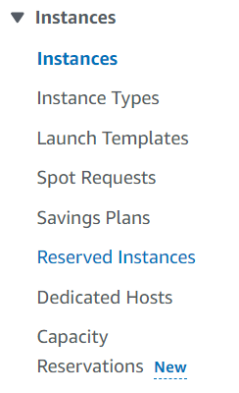



* Name our instance of your choice. Select OS of your choice.

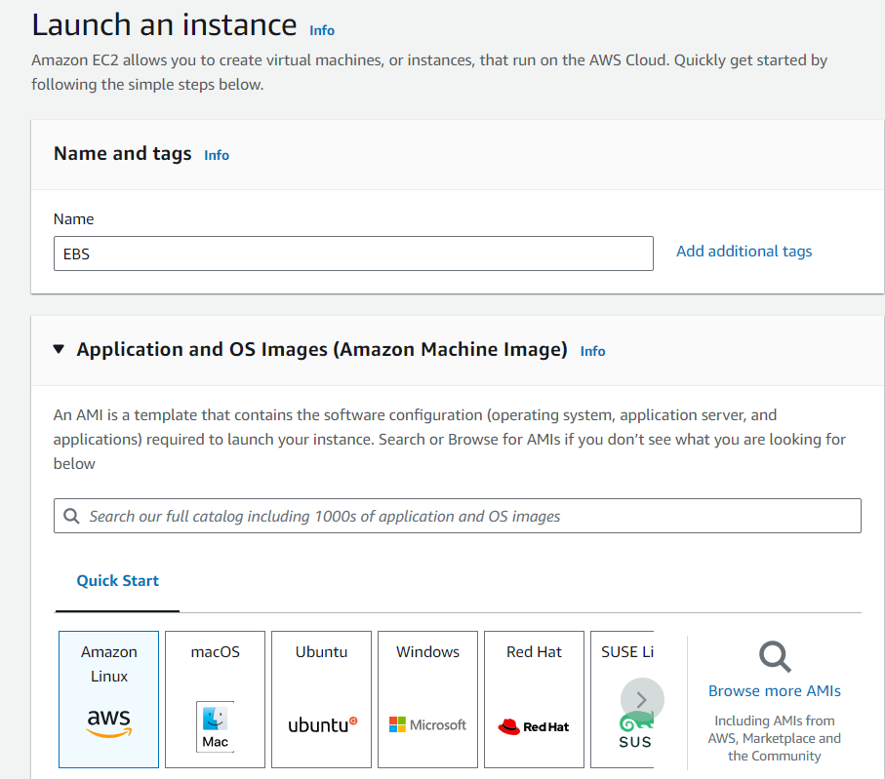

* We have to create a key pair. So, click on Create new key pair option
* Here select our custom VPC, select availability zone under subnet, Enable the Auto-aasign public IP option and finally launch instance.

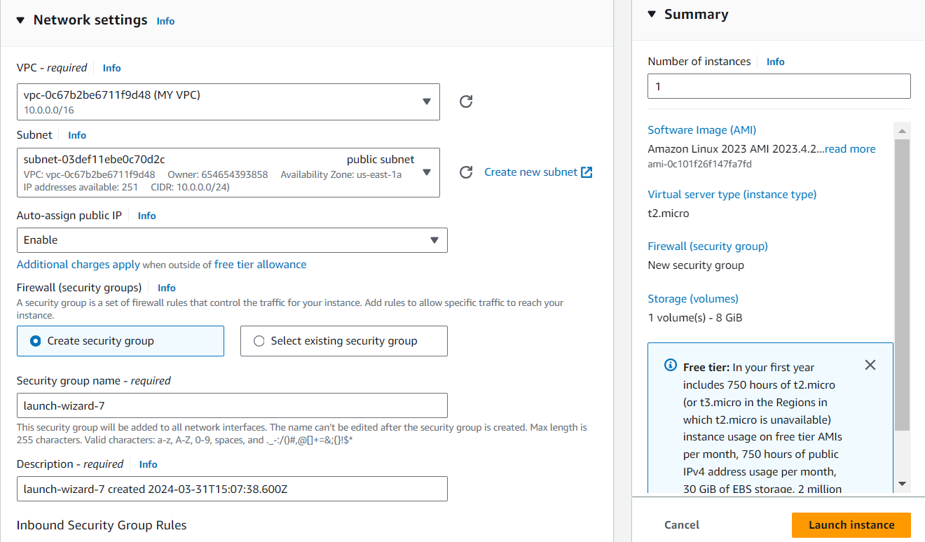

* To create new volume, click on Volumes option from menu under Elastic Block Store.

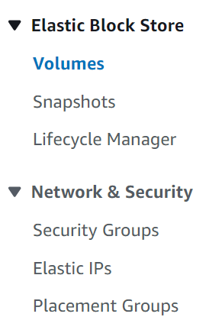

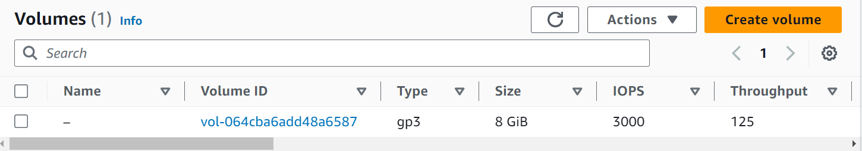

* Now Volume settings page will open and here we have to select Volume type based on our requirement, we have mention size, we have to specify the availability zone and finally click on Create volume button.
* Note: We have to EBS storage in same availability zone that our instance is running.

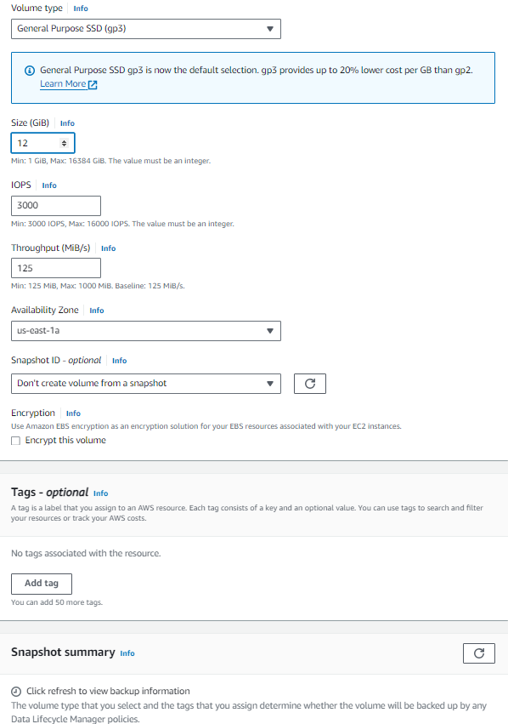

* Now we can our new volume of 12 created successfully . Now, select our volume, click on Actions and Click on Attach volume.

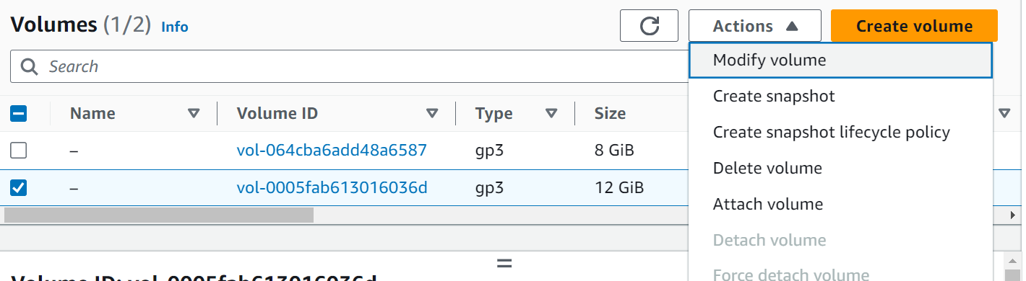

* Now we have to select our instance and finally click on Attach volume button.

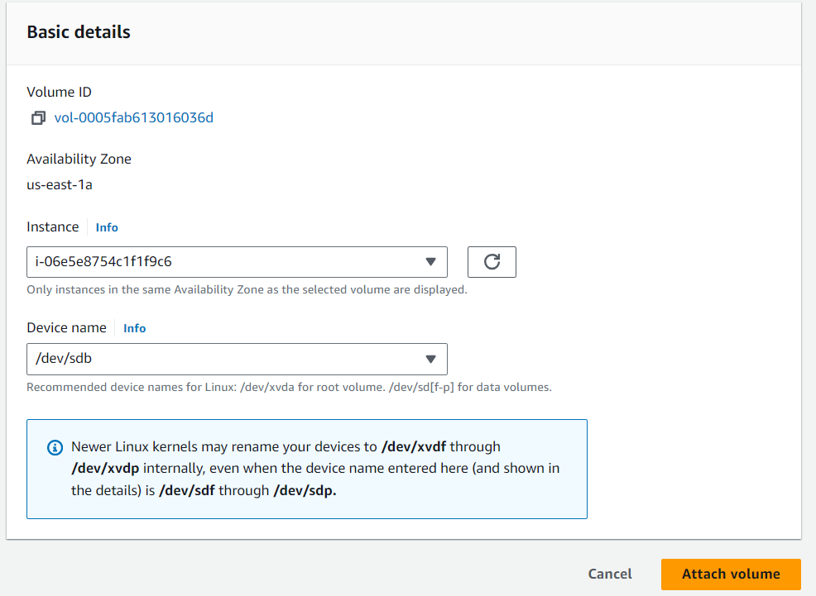

* Go to instances, select our instance and click on Connect

F

* Click on Connect button in instance connect page.

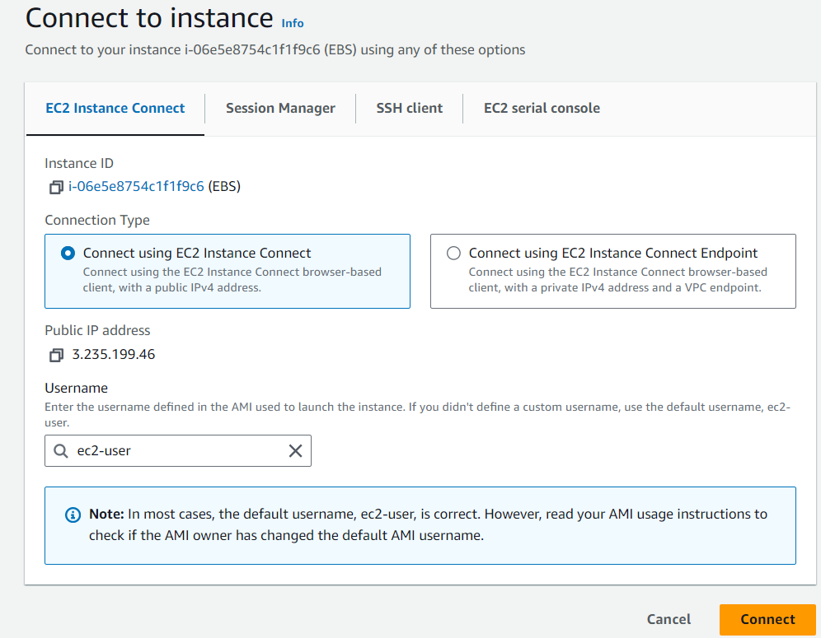

* Now we have connected to our server. Give sudo -i to change to root user.

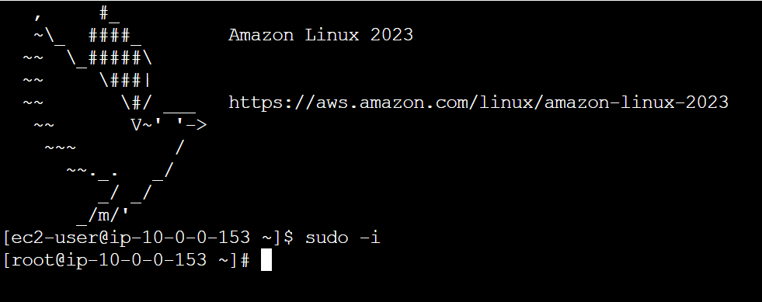

* df –h – to check the disk space
* lsblk – to list out block devices
* file –s /dev/xvdb – to check whether we have file system on this device.

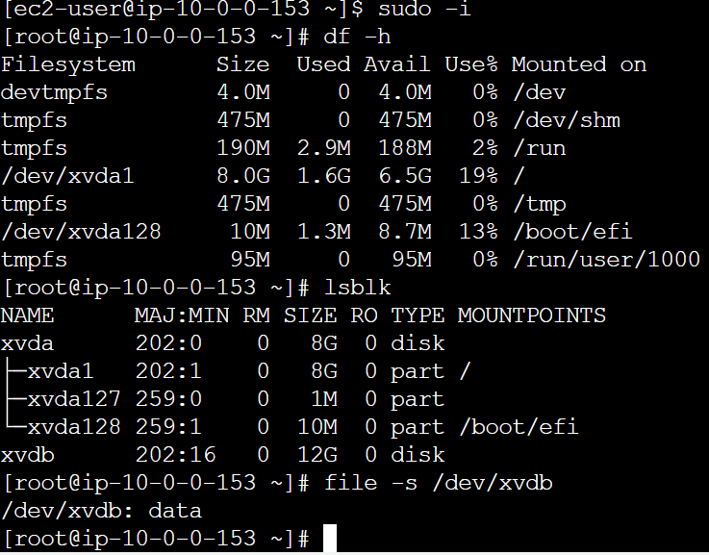

* from above its clear that we don’t have a file system. To create fiile system use below command and check do we have file system or not.
* mkfs -t xfs /dev/xvdf



* its clear that now we have file system. Now crate one nested directory to mount our volume.
* mkdir –p charan/cherry
* And finally mount volume by using below command
* mount /dev/xvdb charan/cherry
* Finally give df –h – to check whether our volume is attached or not.

